平成28年12月19日現在

**遊佐町イメージキャラクター ポーズ一覧**

1. **米～ちゃん**

|  |  |  |  |
| --- | --- | --- | --- |
|  |  |  |  |
| A-1 | **A-2** | **A-3** | **A-4** |



|  |  |  |  |
| --- | --- | --- | --- |
|  |  |  |  |
| A-5 | **A-6** | **A-7** | **A-8** |



|  |  |  |  |
| --- | --- | --- | --- |
|  |  |  |  |
| A-9 | **A-10** | **A-11** | **A-12** |

1. **ライちゃん：妹**

|  |  |  |  |
| --- | --- | --- | --- |
|  |  |  |  |
| B-1 | **B-2** | **B-3** | **B-4** |

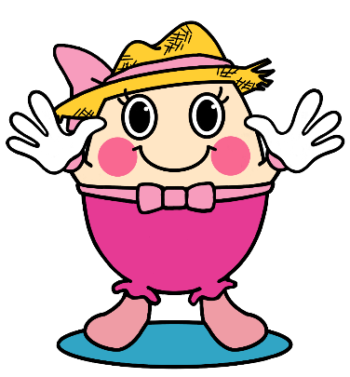

|  |  |  |  |
| --- | --- | --- | --- |
|  |  |  |  |
| B-5 | **B-6** | **B-7** | **B-8** |

1. **米～ちゃん&ライちゃん**

|  |  |
| --- | --- |
|  |  |
| C-1 | **C-2** |

|  |  |
| --- | --- |
|  |  |
| C-3 | **C-4** |

1. **遊田（ゆうた）：お父さん**　　　　　　　　　**E.　まんまママ：お母さん**

|  |  |  |  |
| --- | --- | --- | --- |
|  |  |  |  |
| D-1 | **D-2** | **E-1** | **E-2** |

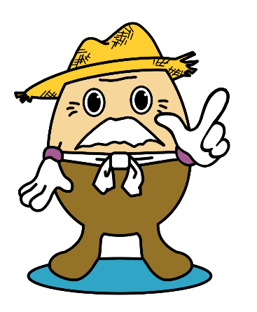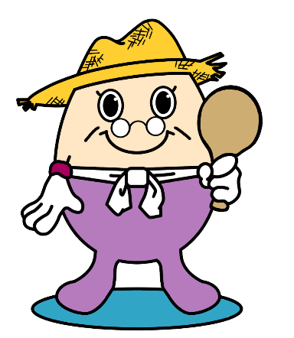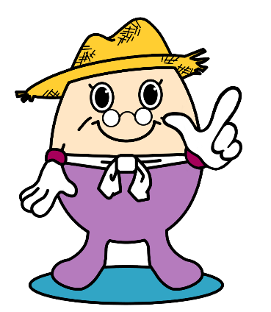**F.　わらぞう：おじいちゃん　　　　　　　　　　 G.　遊米（ゆめ）：おばあちゃん**

|  |  |  |  |
| --- | --- | --- | --- |
|  |  |  |  |
| F-1 | **F-2** | **G-1** | **G-2** |